Addis Ababa University

Data Science and Cloud Computing in Bioinformatics
Assignment II
Data Collection & Data Wrangling

Name: Beyene Chalchisa
ID N_{O}: GSR/4596/18

Augest, 2026

Data Cleaning and Preprocessing Report for a Bioinformatics Dataset
1. Introduction
Data quality is an essential aspect of bioinformatics and data science since biological data may have issues related to missing values, duplicates, inconsistencies among categorical labels, biologically invalid measurements, and outliers. These issues should be detected and appropriately dealt with otherwise they may impact statistical analyses, data visualization, machine learning, and biological interpretations.
In the current study, the dataset “messy_data_module_2.csv” was inspected and cleaned using Python and Pandas package. The dataset has sample-level data consisting of Sample_ID, Species, Tissue, Sex, Age, Treatment and gene expression measures for GeneA, GeneB and GeneC. Also, other variables, such as mean and log2 transformation of gene expression measurements, were calculated during the cleaning process.
The main goals of the data cleaning were to detect data quality issues, make appropriate decisions about handling missing values and duplicates, prepare categorical variables, explore biologically invalid data and possible outliers and transform gene expression measurements.
2. Problems Identified in the Dataset
The first stage involved inspecting the structure and quality of the dataset using Pandas functions such as head(), tail(), shape, columns, info(), describe(), and isnull().sum().
The missing-value assessment identified missing observations in several variables. Specifically, Age contained 2 missing values, GeneB contained 1 missing value, and GeneC contained 2 missing values. Corresponding log2-transformed variables also contained missing values because their original gene-expression measurements were missing. The variables Sample_ID, Species, Tissue, Sex, Treatment, and MeanExpression initially contained no missing values.
The dataset also contained one duplicate record. Duplicate Sample_ID values were investigated separately to determine whether the duplicated record represented an exact duplicate or potentially a valid replicate.

In addition, categorical variables were examined for inconsistent representations. Variables such as Species, Tissue, Sex, and Treatment were checked using unique-value and frequency tables. Differences in capitalization, whitespace, and abbreviated labels can result in categories that should represent the same biological group being treated as separate categories during analysis.
The second problem with biological data was related to the Age variable. Values of age that were not biologically plausible could be treated as incorrect. The age range of 0 to 120 years was used as an indication criterion and any other values had to be verified (CDC, 2026).

3. Treatment of Missing Values
Missing values were handled according to the type of variable.
- For numeric variables, missing observations were replaced using the median of the corresponding variable. The median was selected because it is less sensitive to extreme observations than the mean. This is particularly useful when biological measurements may have skewed distributions or potential outliers.
The following approach was used:
numeric_columns = df.select_dtypes(include="number").columns
for col in numeric_columns:
if df[col].isnull().sum() > 0:
df[col] = df[col].fillna(df[col].median())
- For categorical variables, missing values were replaced using the mode, which represents the most frequently occurring category.
categorical_columns = df.select_dtypes(include=["object", "category", "string"]).columns
for col in categorical_columns:
if df[col].isnull().sum() > 0:
mode_value = df[col].mode()[0]
df[col] = df[col].fillna(mode_value)
- After treatment, missing values were checked again using:
df.isnull().sum()
This verification step was important because it confirmed whether the selected cleaning procedures successfully removed the missing observations.
However, replacing missing biological measurements with the median can introduce bias if a large proportion of observations are missing or if the missingness is related to biological characteristics. Therefore, in a real research study, the mechanism and proportion of missing data should be investigated before imputation.

4. Duplication Detection
Duplications were detected by:
df.duplicated().sum()
There was only one exact duplicate detected in the analysis. The duplications were reviewed using:
df[df.duplicated(keep=False)]
The duplication of Sample_ID was also analyzed to see if there is any duplication of biological samples.
One key point in bioinformatics is that two samples that share the same ID are not necessarily mistakes. These can be either replicates in technique, sequencing, library, repeat experiments, or independently prepared samples. As such, it is not correct to simply delete the duplicates without first understanding the experimental design.
In this experiment, the exact duplicate was removed by:
df = df.drop_duplicates()
And it was verified that there were no exact duplicates in the dataset.
5. Standardization of Categorical Features
Categorical features were standardized to make sure that equivalent categories are not considered as distinct entities. For instance, blank spaces were removed and texts made lowercase:
df["Tissue"] = (df["Tissue"].astype("string").str.strip().str.lower())
The same operation was performed on Species, Sex and Treatment.
- Standardization of sex abbreviations:
df["Sex"] = df["Sex"]. replace ({"m": "male", "f": "female"})
- Standardization of treatment abbreviations:
df["Treatment"] = df["Treatment"]. replace({ "ctrl": "control", "trt": "treated"})
Frequency distributions were made before and after cleaning, which made it possible to measure changes in category distribution and conclude about duplication of categorical labels.

6. Non-Biological Values
For the Age variable, values that are not within the biologically valid range were sought.
- The following criterion was employed:
(df["Age"] < 0) | (df["Age"] > 120)
Such values were treated as non-biologically valid. A non-biological value needs to be cross-checked by consulting the original source of the measurement. If the correct value cannot be determined, the value should not be arbitrarily adjusted only for the purpose of having complete data.
- The non-biological value was replaced with missing:
df.loc[ (df["Age"] < 0) | (df["Age"] > 120),"Age"] = np.nan
The resultant missing value could then be dealt with according to the predefined missing data approach.
Such an approach ensures that there is data integrity since it is possible to distinguish between a biologically recorded value and a non-biological one.
7. Outlier Investigation
Outliers for GeneA, GeneB, and GeneC expression were identified based on the interquartile range (IQR).
Quartile 1 (Q1), Quartile 3 (Q3), and IQR were found for each of the genes:
IQR = Q3 − Q1
Possible outliers could be identified based on the following formula:
Lower limit = Q1 − 1.5 × IQR
Upper limit = Q3 + 1.5 × IQR
Data points outside these lower and upper limits could be considered possible outliers. Boxplots for the genes provided additional visual representation of distribution of expression values. It is worth noting that an IQR outlier cannot be considered an erroneous observation. In case of biological data, an extreme value of expression can be a true biological difference, disease-related effect, or a feature of the sample.
Thus, possible outliers had to be investigated and not just eliminated. A scientist had to review the information about laboratory procedures, sequencing quality, samples, and experiments conducted

8, Re-shaping the Dataset
The dataset was re-shaped from wide-form to long-form to enable the statistical analysis and visualizations of the gene expression dataset. In the original wide-form of the dataset, the expressions of GeneA, GeneB, and GeneC were found in different columns. The following code used Pandas melt() method to restructure the dataset:
long_df = df.melt(
id_vars=["Sample_ID", "Tissue", "Sex", "Treatment"],
value_vars=["GeneA", "GeneB", "GeneC"],
var_name="Gene",
value_name="Expression)
Sample_ID, Tissue, Sex, and Treatment were maintained as identifier variables. The expression levels of GeneA, GeneB, and GeneC were transformed from separate columns to two columns namely Gene, which refers to the name of the gene and Expression which holds the gene expression levels.
9. Data Transformation
The mean expression of the three genes was calculated to provide a simple summary measure:
df ["Mean Expression"] = df[ ["GeneA", "GeneB", "GeneC"]].mean(axis=1)
- Log2 transformation was also applied to the gene-expression variables:
df["GeneA_log2"] = np.log2(df["GeneA"] + 1)
df["GeneB_log2"] = np.log2(df["GeneB"] + 1)
df["GeneC_log2"] = np.log2(df["GeneC"] + 1)
The +1 prevents problems when an expression value is zero.
Log2 transformation reduces the influence of very large expression values and can make highly skewed measurements easier to visualize and analyze. The transformed data were inspected using descriptive statistics and box plots displayed below.
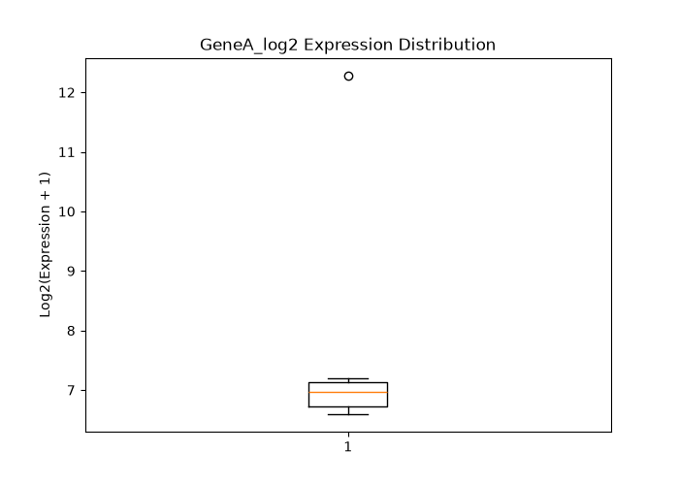
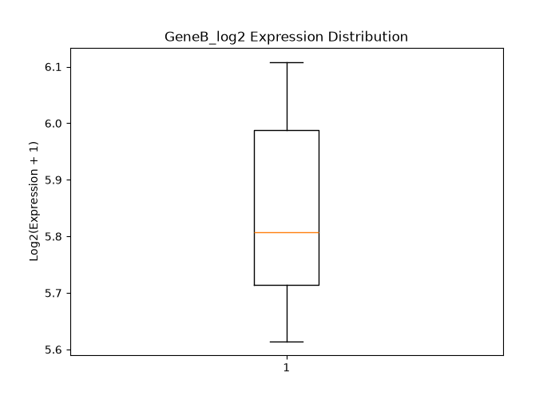
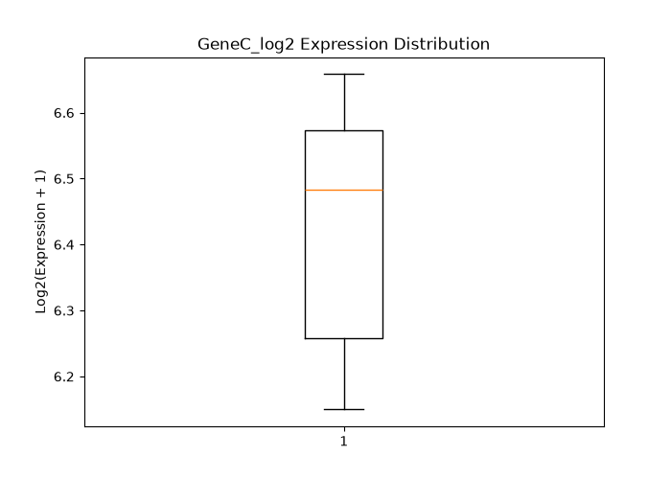

10. Final Dataset and Validation
After cleaning, standardization, duplicate handling, invalid-value treatment, and transformation, the final dataset was saved as “cleaned_bioinformatics_data.csv”.
The dataset was validated using:
print(df.isnull().sum())
print(df.duplicated().sum())
print(df.shape)
print(df.describe())
The final validation checked missing values, duplicate records, categorical values, dataset dimensions, and numerical distributions.
The final dataset therefore provides a cleaner and more consistent input for subsequent statistical analysis, visualization, and bioinformatics interpretation.
11. Limitations
Several limitations should be considered.
- First, median and mode imputation are simple methods and may reduce the natural variability of the data. They do not account for the biological mechanism that produced the missing observations.
- Second, the definition of an invalid age as outside 0–120 years is a general rule and may not be appropriate for every study population. Biological and study-specific knowledge should be used when defining valid ranges.
- Third, the IQR method identifies statistical outliers but cannot determine whether an observation is biologically erroneous. Outlier removal should therefore be based on additional experimental and biological evidence.
- Fourth, the dataset appears to contain simplified gene-expression variables. Real RNA-seq analysis generally requires additional steps such as sequencing-quality assessment, adapter removal, alignment or transcript quantification, count filtering, normalization, and appropriate statistical modeling.
- Finally, standardizing categorical variables improves consistency but does not guarantee that the resulting categories are biologically correct. The researcher should verify category definitions against the original study design and metadata.
Interpretation;
The data quality assessment revealed that the dataset included 16 cases both before and after the cleaning process. There is one duplicate case that has yet to be scientifically proven and can be deleted. The number of missing values rose from 7 to 8 because the biologically inconsistent value of age −5 was turned into a missing value and not replaced by an estimated value. There are no more invalid ages since the value of −5 is now missing. The standardization process greatly enhanced the categorical variables: Tissue dropped from 7 to 3, Sex from 6 to 2, and Treatment from 6 to 2. One possible gene expression outlier remains in the dataset after cleaning as statistical outliers should not be removed without investigating their cause.
Conclusion
Data cleaning efforts have been able to detect several quality problems that include missing values, duplicate data, inconsistent representation of categorical variables, potentially invalid biological data, and gene expression outliers. Median imputation was used for handling missing numeric data, mode imputation was used for missing categorical data, exact duplicates were dropped, categorical variables were made consistent, and ages deemed invalid were considered missing values.
Summary statistics of mean expression and log2 transformation were used for gene expression variables. Investigation of outliers was performed using IQR approach and boxplots instead of automatic deletion of the outliers.
The resulting cleaned data set called cleaned_bioinformatics_data.csv is now a more consistent data set for use in statistical analysis. It is always important to note that data cleaning should be informed by the biological context of the experiment. Data cleaning will ultimately improve future statistical analysis.
Raw sequencing data collection (Task 9)
The raw data for sequencing were obtained from the NCBI Sequence Read Archive (SRA) with the accession code SRR3129514 (gs, 2026). The data were downloaded using Ubuntu Linux operating system with the use of prefetch command. They were then transformed from SRA file format to FASTQ file format using fasterq-dump command, followed by compression with the help of gzip command. Finally data was changed to FASTA Format.
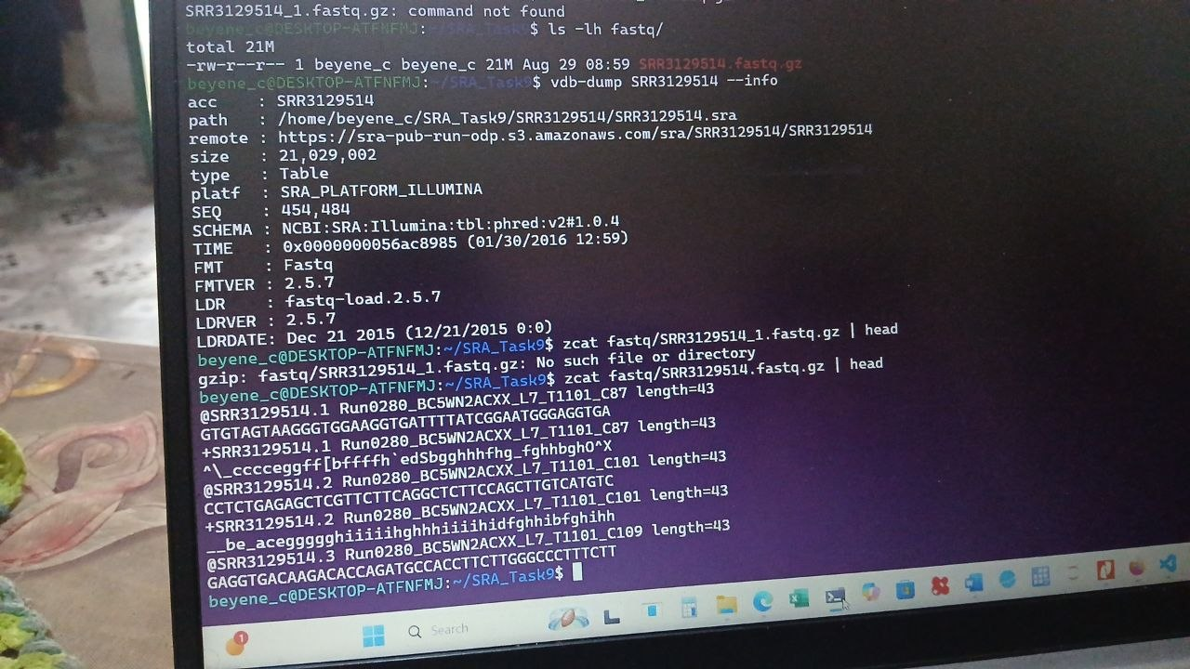

Workflow Raw sequencing data collection
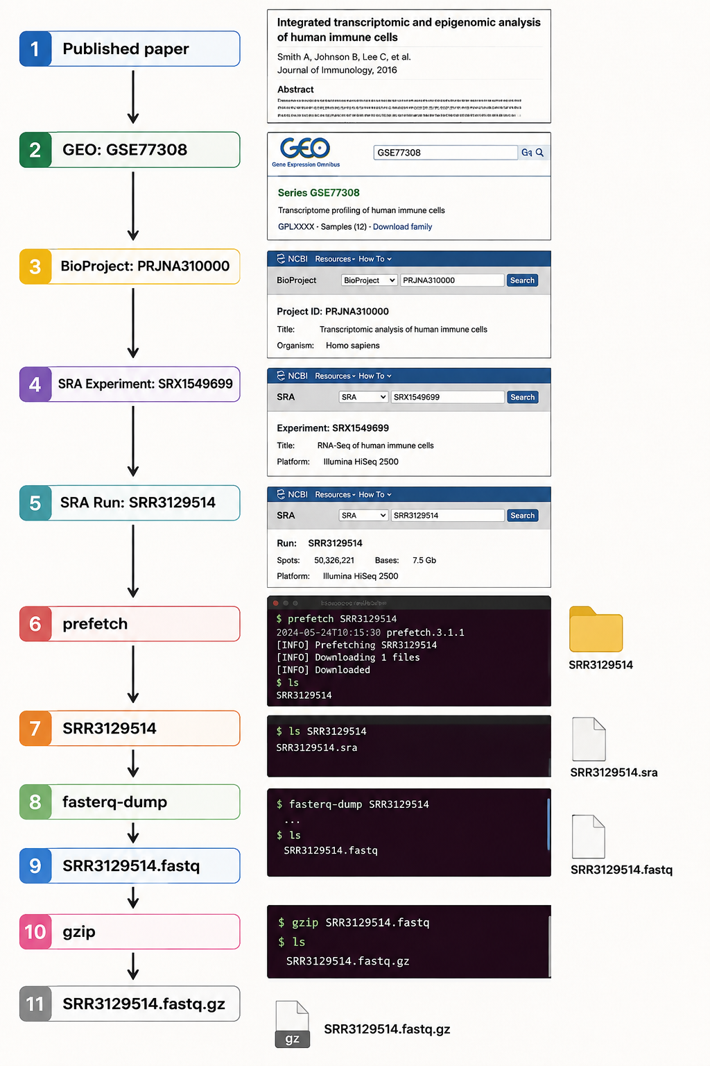

Reference

Centers for Disease Control and Prevention (CDC). (2026). Oh My...You Haven't Aged a Bit! National Syndromic Surveillance Program (NSSP). CDC — Age data-quality guidance
https://www.ncbi.nlm.nih.gov/sra/

